A mini project report on
STOCK PREDICTION USING MACHINE LEARNING
submitted in partial fulfilment of the requirement for the award of
the Degree of
BACHELOR OF TECHNOLOGY
IN COMPUTER SCIENCE AND ENGINEERING

Submitted By
BURRA HARSHITHA (21XU1A0518)
KATARAM DIKSHITHA (21XU1A0536)
GUDAVALI KALYAN (21XU1A0543)

Under the Guidance of
MR. P ABDUL SUBHAHANALLA Associate Professor


CSI WESLEY INSTITUTE OF TECHNOLOGY & SCIENCES
1-7-132/142, P.G ROAD,
OPP: PARADISE SECUNDERABAD-500003
Department of Computer Science and Engineering

(2024-2025)


CSI WESLEY INSTITUTE OF TECHNOLOGY & SCIENCES
1-7-132/142, P.G ROAD,
OPP: PARADISE SECUNDERABAD-500003
Department of Computer Science and Engineering

BONAFIED CERTIFICATE

This is to certify that the project entitled " STOCK PREDICTION USING MACHINE LEARNING " is a
bonafide work carried out by the following students during the period 2024-2025 in partial fulfilment of the
requirements for the award of degree of "Bachelor of technology in computer science and engineering" from
CSI Wesley Institute of Technology and Sciences, secunderabad affiliated to Jawaharlal Nehru Technological
University, Hyderabad (JNTUH) under my guidance and supervision.
The results embodied in the project work have not been submitted to any other university or institute for the
award of any degree or diploma.

INTERNAL GUIDE
MR . P ABDUL SUBHAHANALLA

External examiner
Principal
P.M YOHAN



Acknowledgement

I would like to express my sincere gratitude to my project guide MR. P ABDUL SUBHAHANALLA for giving
me the opportunity to work on this topic. It would never be possible for me to take this project to this level without
his innovative ideas and his relentless support and encouragement.

My sincere thanks to Mr. P ABDUL SUBHAHANALLA, Associate Professor of Computer Science and
Engineering, for his valuable guidance and encouragement which has played a major role in the completion of the
project and for helping us by being an example of high vision and pushing towards greater limits of achievement.

I would like to express a deep sense of gratitude towards Dr. P.M Yohan, Principal, CSI WITS for always being
an inspirational for always encouraging us in every possible way.

I would like to thank my parents for allowing me to realize my potential, all the support they have provided me
over the years was the greatest gift anyone has ever given me and for teaching me the value of hard work and
education. My parents have offered me with tremendous support and encouragement, thanks to my parents for all
the moral support and the amazing opportunities they have given me over the years.

BY,

BURRA HARSHITHA (21XU1A0518)
KATARAM DIKSHITHA (21XU1A0536)
GUDAVALI KALYAN (21XU1A0543)

DECLARATION

A Mini project report titled " STOCK PREDICTION USING MACHINE LEARNING " is submitted for the
partial fulfilment for the award of degree of Bachelor of technology in Computer science engineering from
Jawaharlal Nehru Technological University, Hyderabad (JNTUH).
This is a bonafide record of the work carried out by us and the results embodied in this project have not been
reproduced/copied from any source.
This Mini project report is not submitted for the award of any degree from any university

BURRA HARSHITHA (21XU1A0518)
KATARAM DIKSHITHA (21XU1A0536)
GUDAVALI KALYAN (21XU1A0543)

Table Of Contents

SL. No. Topic Page No

Abstract...................................................................................... 7
1 Introduction................................................................................ 9
1.1 Background of the study.............................................. 11
1.2 Problem Statement....................................................... 12
1.3 Existing System.......................................................... 13
1.4 Advantages................................................................... 14
1.5 Drawbacks.................................................................... 14
1.6 Proposed System.......................................................... 15
1.7 Methodology................................................................ 16
1.8 Objectives of the Project.............................................. 18
1.9 Organization of the Project.......................................... 18
2 Literature Survey........................................................................ 19
3 Prediction of Stock using Machine Learning............................. 20
3.1 Architecture of the System........................................... 21
3.2 Data flow diagram------------------------------------------24
3.3 use case diagram --------------------------------------------25
4 Module Design........................................................................... 26
4.1 Implementation of Modules......................................... 26
4.2 Random Forest............................................................. 28
4.3 Linear Discriminant Analysis...................................... 29
4.4 sample code --------------------------------------------- 30
4.5 smple data set 1---------------------------------------------- 34
4.6 sample data set 2 ------------------------------------------------ 38
5 Test cases --------------------------------------------------- 42
6 Results and Discussions............................................................. 44
6.1 Comparison of Modules............................................... 44
6.2 Model Performance Metrics......................................... 44
6.3 Results.......................................................................... 45
7 Conclusions and Future Work.................................................... 46
8 References.................................................................................. 49
9 Glossary...................................................................................... 50

Abstract

Predicting stock market movements remains a significant challenge, with increasing interest in leveraging
social media data to enhance prediction accuracy. Social media platforms, particularly Twitter, offer valuable
insights into public sentiment and opinions on various topics, including stock performance. This study the
correlation between stock price fluctuations and public sentiment expressed in tweets about specific companies.
We utilize sentiment analysis and supervised machine learning techniques to analyse tweets collected via the
Twitter API and stock market data sourced from the Yahoo API.
Our methodology involves extracting and preprocessing tweet data to identify sentiment trends, followed
by training machine learning models to correlate these trends with stock price movements. Specifically, we
focus on the sentiment expressed in tweets and its impact on stock prices, testing the hypothesis that positive or
negative sentiments on social media can influence stock pretends.
The study reveals a notable correlation between stock price variations and public sentiment as captured
through Twitter. Positive sentiments are associated with an increase in stock prices, while negative sentiments
correspond to declines. This relationship highlights the potential of social media sentiment as a predictive tool
for stock market behaviour.
The results underscore the effectiveness of integrating sentiment analysis with traditional stock market
prediction methods, offering a promising approach to understanding and forecasting stock price dynamics based
on public opinion.

 |  | List of Figures
S. No |  | Name of the Figure Page No
Figure 2.1 |  | Literature Survey …………………………………… 19
Figure 3.1 |  | Architecture of the system……………………………. 21
Figure 3.2 |  | Data flow diagram ----------------------------------------- 24
Figure 3.3 |  | Use case diagram------------------------------------------ 25
Figure 6.1.1 |  | Comparison of Models……………………………....... 44
Figure 6.2.1 |  | LDA Performance Metrics……………………………. 44
Figure 6.2.2 |  | RF Performance Metrics……………………………… 44
Figure 6.3.1 |  | Interface………………………………………………. 45

1. INTRODUCTION

Stock market prediction involves using machine learning (ML) to forecast future stock prices or market
trends. Traditional methods relied heavily on historical data analysis and economic indicators, but ML introduces
more sophisticated models that can handle vast amounts of data and identify complex patterns. By analysing
historical prices, volumes, and technical indicators like moving averages and the relative strength index, ML
models can provide more accurate predictions.

Various machine learning techniques are employed for stock market prediction. Supervised learning models, such as Linear Regression, Support Vector Machines (SVM), and Neural Networks, are trained on historical data with known outcomes. Unsupervised learning techniques, like clustering, can identify patterns without labelled data, while reinforcement learning develops trading strategies by learning from market interactions. Feature engineering, which involves creating meaningful features from raw data, plays a crucial role in enhancing model performance.

Despite the advancements, stock market prediction faces several challenges. Market volatility and the multitude of factors influencing stock prices make predictions inherently uncertain. Data quality issues, such as incomplete or noisy data, can affect model accuracy. Additionally, overfitting, where a model performs well on training data but poorly on new data, remains a concern. Evaluating models using metrics like Mean Absolute Error (MAE) and Root Mean Squared Error (RMSE) helps ensure reliability.

Applications of ML in stock market prediction include algorithmic trading, where automated strategies are based on model predictions, and risk management, which involves assessing and managing investment risks. Market sentiment analysis, using natural language processing to gauge sentiment from news and social media, is another important application. Tools like Python and its libraries (NumPy, pandas, scikit-learn, TensorFlow) are widely used for developing and implementing these ML models.

Stock market predictio involves utilizing machine learning (ML) to forecast future stock prices or market
trends, surpassing traditional methods that relied heavily on historical data and economic indicators. ML
introduces advanced models capable of analyzing vast amounts of data to uncover intricate patterns. By
examining historical prices, trading volumes, and technical indicators like moving averages and the relative
strength index (RSI), ML models aim to provide more accurate and insightful predictions. This technological
advancement empowers traders and investors to make more informed decisions.

Several machine learning techniques are employed in stock market prediction. Supervised learning
models, such as Linear Regression, Support Vector Machines (SVM), and Neural Networks, are trained on
historical datasets with known outcomes to predict future trend. Unsupervised learning methods, lik clustering,
are used o detect patterns in unlabeled data. Additionally, reinforcement learning has emerged asa promising
approach, where models learn optimal trading strategies through continuous interaction with the market
environment.A critical aspect of successful prediction is feature engineering,which involves transforming raw
data into meaningful features that improve model accuracy and performance.

Despite significant progress, stock market prediction faces several challenges. The inherent volatility of
financial markets,coupled with thediverse factorsinfluencin stock prices, makes accurate prediction a complex
task.Data quality issues,such asincomplete ornoisy datasets,can further impact model reliability. Another major
hurdle is overfitting, where models perform exceptionally well on training data but fail to generalize to new,
unseen data.To address these issues models are evaluated using performance metrics like Mean Absolute Error
(MAE) and Root Mean Squared Error (RMSE), ensuring robust and reliable predictions.

The application of ML in stock market prediction are vast.Algorithmi trading leverages modelpredictions
to execute automated trading strategies at high speeds,enhancingefficiency and profitability.Risk management
tools assess and mitigate investment risks using predictive insights, while market sentiment analysis employs
natural language processing to extract sentiment from news articles and social media, providing additional
context to market movements. Python, along with its robust libraries like NumPy, pandas, scikit-learn, and
TensorFlow, serves as a popular toolkit for developing and implementing these ML models, enabling efficient
data processing, analysis, and model training.

1.1 Background of the Study
Stock prediction, or stock market forecasting, involves the attempt to determine the future value of a company’s stock or other financial instruments traded on exchanges. This practice is fundamental to both individual investors and financial institutions, aiming to maximize returns and manage risk. Techniques such as fundamental analysis, which examines a company's financial health and market position, and technical analysis, which focuses on price patterns and trading volumes, have long been cornerstones of stock market forecasting.
In recent years, however, the landscape of stock prediction has been transformed by the advent of big data and advanced machine learning algorithms. These technologies enable the processing and analysis of vast amounts of data from diverse sources, including financial statements, news reports, and even social media platforms. Among these new data sources, Twitter has emerged as particularly influential due to its real-time reflection of public sentiment and opinion.
Researchers have found that the sentiments expressed on Twitter can provide valuable insights into market behaviour. Sentiment analysis, a technique used to extract and quantify emotions from textual data, has been applied to Twitter data to gauge the public mood towards companies and their stocks. For instance, positive tweets about a company can indicate rising investor confidence and potential increases in stock prices, while negative tweets can signal declining confidence and potential drops in stock prices.
The integration of sentiment analysis into stock prediction models represents a significant advancement in the field. By combining traditional financial data with real-time sentiment data from social media, these models can provide more accurate and timely predictions. Machine learning algorithms, capable of learning and adapting to new data, enhance the predictive power of these models by identifying complex patterns and relationships that may not be apparent through traditional analysis alone.
Stock prediction has evolved from solely relying on historical and financial data to incorporating real-time sentiment analysis from social media platforms like Twitter. This integration has the potential to enhance the accuracy of stock market forecasts, providing investors with more comprehensive tools to navigate the complexities of the financial markets.

1.2 Problem Statement
Predicting stock market movements using social media sentiments is an intriguing research area, with Twitter providing a wealth of data on public opinion. Despite evidence linking the overall mood on Twitter to market indices like the Dow Jones Industrial Average (DJIA), the specific impact of tweets on individual company stock prices is not well understood. This study aims to explore the relationship between a company's stock price changes and the sentiments expressed in tweets about that company.

The main challenge is to determine if positive tweets about a company encourage investment and lead to higher stock prices, while negative tweets have the opposite effect. To address this, we will use sentiment analysis and supervised machine learning techniques on a dataset of tweets related to specific companies. By correlating tweet sentiments with stock price movements, we aim to uncover meaningful patterns.

The goal is to demonstrate a significant correlation between stock price changes and public sentiments on Twitter, enhancing our understanding of social media's influence on financial markets. This study aims to show how real-time sentiment analysis of social media data can improve financial forecasting, providing valuable insights for investors and market analysts.

1.3 Existing System

Current stock prediction systems using machine learning leverage historical stock data and a variety of technical indicators to forecast future price movements. These systems typically employ algorithms like Linear Regression, Support Vector Machines (SVM), Random Forests, and Neural Networks to identify patterns and trends in the data. They analyse historical price movements, trading volumes, and other market-related metrics to predict future stock prices. These models are trained on historical data and validated using a portion of the data to ensure accuracy and robustness in their predictions.

One common approach in existing systems is the use of time series analysis, where models like ARIMA (Auto-Regressive Integrated Moving Average) or LSTM (Long Short-Term Memory) networks are used to capture temporal dependencies and trends in stock prices. These models are particularly adept at handling sequential data and can forecast future prices based on past performance. Additionally, technical indicators such as Moving Averages, Relative Strength Index (RSI), and Bollinger Bands are often incorporated into these models to enhance their predictive capabilities.

Moreover, sentiment analysis has begun to play an increasingly important role in stock prediction systems. By analysing news articles, financial reports, and social media data, machine learning models can gauge public sentiment and its potential impact on stock prices. Natural Language Processing (NLP) techniques are employed to process and analyse text data, extracting sentiment scores that are then used as additional features in the predictive models. This multi-faceted approach, combining traditional financial metrics with sentiment analysis, aims to provide a more comprehensive and accurate prediction of stock market movements.

1.4 Advantages
- Data Accessibility and Variety: Existing stock prediction systems like Quandl, Alpha Vantage, and Stock Viz offer access to a wide range of financial data, including historical prices, market indicators, and economic metrics. This comprehensive data accessibility allows analysts and traders to build robust models by leveraging diverse datasets.
- Ease of Integration and Use: Many of these systems provide user-friendly APIs, making it easy for developers to integrate financial data into their applications, trading algorithms, or research projects. Platforms like Alpha Vantage and Quandl also offer extensive documentation and support for multiple programming languages, enhancing usability for both novice and experienced users. This ease of integration accelerates the development of predictive models and tools.
- Advanced Analytical Tools: Platforms such as Stock Viz offer specialized tools tailored to specific markets, like the Indian stock market. These tools often include technical analysis indicators, financial ratios, and portfolio management features, which help users perform in-depth analysis and make informed investment decisions. The availability of such advanced analytical tools can significantly enhance the accuracy and reliability of stock predictions.

1.5 Drawbacks
- Data Quality and Consistency: While these platforms provide a wealth of data, the quality and consistency of the data can sometimes be an issue. Users often need to spend additional time cleaning and preprocessing the data to ensure accuracy, which can be a significant drawback.
- Limited Customization and Flexibility: Despite offering a variety of data, existing systems might lack the flexibility needed for highly customized prediction models. Customizing the models to cater to unique needs often requires additional effort and resources, which can be a limitation for some users.
- Dependency on Historical Data: Most stock prediction systems rely heavily on historical data to forecast future trends. Market conditions are influenced by numerous unpredictable factors such as geopolitical events, regulatory changes, and sudden economic shifts. Relying solely on historical data may not always capture these dynamic elements, leading to potential inaccuracies in predictions.

1.6 Proposed System
Combining sentiment analysis of Twitter data with high-frequency data analysis presents a novel strategy to bolster stock market prediction accuracy. This innovative method harnesses the vast stream of real-time information shared on platforms like Twitter to gauge public sentiment toward specific companies or stocks. Through meticulous data collection and preprocessing, tweets related to targeted entities are curated and cleansed to extract meaningful sentiment insights.

- Enhanced Sentiment Insights: Integrating real-time sentiment analysis from Twitter with stock market data allows for a more nuanced understanding of public opinion toward specific companies. By using natural language processing (NLP) techniques, tweets are categorized into positive, negative, or neutral sentiments. This real-time sentiment gauge complements traditional financial data, offering timely insights into market sentiment shifts. The result is a dynamic dataset that reflects both the market fundamentals and public perceptions, providing a comprehensive view of investor sentiment and its potential impact on stock price movements.
- Granular Market Data Capture: High-frequency data analysis involves tracking minute-by-minute fluctuations in stock prices, trading volumes, and other market dynamics. This detailed data capture provides insights into short-term price movements, volatility patterns, and trading behaviours that are not apparent in aggregated data. By analysing this granular information, the system can detect rapid changes and trends in the market.
- Integrated Predictive Modelling: Machine learning models are employed to predict stock price movements by learning from a comprehensive dataset that merges historical stock data with real-time sentiment signals. These models leverage the combined insights from both traditional financial metrics and current sentiment trends. By training on this integrated dataset, the models can identify complex relationships and patterns that traditional methods might overlook.
- Historical Validation and Adaptation: The effectiveness of the proposed system is validated against historical data to ensure it accurately adapts to evolving market conditions and sentiment shifts. This validation process involves comparing the model's predictions with actual historical outcomes to assess its performance. By incorporating real-time sentiment data and high-frequency market data, the system can adjust to changing market dynamics and sentiment trends, demonstrating its potential to refine financial forecasting capabilities.

1.7 Methodology

The methodology for stock rate forecasting using sentiment analysis typically involves several key steps.
Here is a generalized outline of the methodology:

1.Data Collection: Collect data from Twitter using the API for tweets related to specific companies or indices, and from financial databases like Yahoo Finance for historical stock prices. This dual-source approach ensures a comprehensive dataset that includes both public sentiment and market performance. Clean tweet data by removing stopwords, punctuation, and URLs, and convert text to lowercase. Apply tokenization, stemming, and lemmatization to normalize the text, preparing it for analysis by reducing it to base forms.

2.Sentiment Analysis: Use tools like VADER or TextBlob to classify tweets into positive, negative, or neutral sentiments. Aggregate sentiment scores over time periods (daily or weekly) to generate indicators reflecting public opinion about a company or market, aiding in predictive modelling.

3.Feature Set Creation: Combine sentiment indicators with historical stock data and technical indicators such as moving averages, RSI, and trading volumes. This comprehensive feature set enriches the dataset, providing a robust input for machine learning models.

4.Model Selection: Implement machine learning algorithms including Linear Regression, Support Vector Machines (SVM), Random Forests, and neural networks to analyse the integrated dataset. Employ Long ShortTerm Memory (LSTM) networks for time-series predictions due to their ability to capture temporal dependencies.

5.Model Training: Train the models using the prepared dataset, applying hyperparameter tuning and crossvalidation techniques to optimize performance. This process involves learning relationships between sentiment indicators, stock prices, and other features to predict future movements accurately.

6.Performance Evaluation: Assess model performance using metrics such as Mean Absolute Error (MAE),
Mean Squared Error (MSE), and accuracy. This evaluation ensures the models’ effectiveness in predicting stock price movements and helps in refining them.

7.Model Deployment: Deploy validated models in a production environment, setting up automated pipelines for
continuous real-time data processing. This deployment ensures the system provides ongoing predictions and
remains accurate with up-to-date information.

8.Real-Time Processing: Ensure the system processes real-time data by integrating automated pipelines for data collection, preprocessing, sentiment analysis, and prediction. This setup maintains the accuracy and timeliness of predictions.

9.Synergistic Approach: Leverage the combined insights from sentiment analysis and machine learning to enhance stock market prediction accuracy. This methodology provides valuable insights for investors and traders by integrating public sentiment and financial metrics.
By following this methodology, researchers and practitioners can utilize sentiment analysis to develop robust and accurate stock-related forecasting models. The iterative nature of the process allows for continuous improvement and refinement, enhancing the model's performance over time.

Linear Discriminant Analysis:
Linear Discriminant Analysis (LDA) improves stock prediction by reducing dimensionality and enhancing feature relevance. It identifies linear combinations of features that best separate different classes, such as stock price movements ("up" or "down"). By projecting high-dimensional data onto a lower-dimensional space, LDA simplifies the dataset, reduces noise, and highlights key features. This streamlining improves the efficiency and accuracy of predictive models like Random Forest or Support Vector Machines (SVM). With fewer, more relevant features, LDA helps in faster training and better performance of these models, ultimately enhancing the reliability of stock market forecasts.

Random Forest:
Random Forest is used in stock prediction by building an ensemble of decision trees, each trained on different subsets of the data through a process called bootstrap aggregating or bagging. In the context of stock prediction, Random Forest can be used for both regression (predicting future stock prices) and classification (predicting stock price movement direction). By aggregating the predictions from multiple decision trees, Random Forest provides a robust prediction that leverages the strengths of various models, making it less sensitive to the noise and volatility inherent in stock market data. This method captures complex interactions between features such as historical prices, trading volumes, and sentiment indicators, leading to more accurate and reliable predictions.

1.8 Objectives of the project

- The real-time framework for collecting, preprocessing, and analysing Twitter data enables timely insights into public perception and investor sentiment, enhancing market analysis accuracy and responsiveness.
- Integrating high-frequency market data analysis enhances forecast accuracy by capturing immediate market reactions alongside traditional financial metrics.
- Incorporating real-time sentiment analysis with high-frequency market data in machine learning models significantly enhances the predictive accuracy of stock price movements.

1.9 Organization of the Project

Chapter-1 Describes an introduction and purpose of the project, the background of the study, defining the problem, already existing systems, and their challenges. Proposed system to overcome the challenges of the existing system. It also includes the methods we used in our application and the main objectives of our project.

Chapter-2 Includes a Literature Survey, which is about what studies we have done to develop this project.
Chapter-3 Describes the Architecture of our Proposed systems; it also gives an overview of the module design of our project.
Chapter-4 Describes the Implementation of our project, the technologies used, and the devices used are explained. It also describes the experiments we have conducted
Chapter-5 Shows the results of our project and the analysis done on the algorithm to choose it and animations to represent emotions.
Chapter-6 Shows us the Final conclusions and future scope i.e., future enhancements of our project.

2. Literature Survey

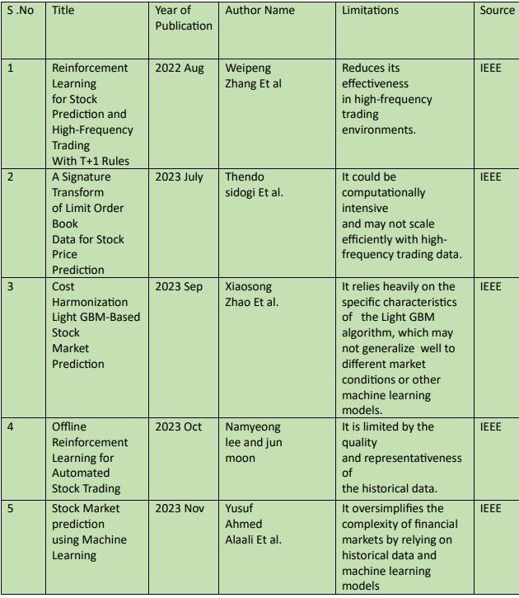

Fig 2.1 Literature Survey

1.The paper "Reinforcement Learning for Stock Prediction and High-Frequency Trading With T+1 Rules" by
Weipeng Zhang et al. explores using reinforcement learning (RL) to optimize stock prediction and high-frequency trading under T+1 settlement rules. It discusses how RL algorithms adapt to the requirement that trades settle one business day after execution. The study focuses on policy learning and reward structures within these constraints, aiming to improve trading performance and decision-making in real-time trading environments.

2.The paper "A Signature Transform of Limit Order Book Data for Stock Price Prediction" by Thendo Sidogi et al. explores using signature transforms to improve stock price forecasting. It shows how these transforms capture complex patterns in high-frequency limit order book data and enhance feature extraction. The study aims to increase prediction accuracy and deepen understanding of market behaviour.

3.The paper "Cost Harmonization LightGBM-Based Stock Market Prediction" by Xiaosong Zhao et al. explores using LightGBM for stock forecasting with a focus on cost harmonization. It details how LightGBM’s efficiency and accuracy are applied to predict stock prices while incorporating cost considerations. The paper covers
LightGBM’s theoretical basis and practical cost optimization techniques, demonstrating how this combination enhances prediction accuracy and manages trading costs.

4.The paper "Offline Reinforcement Learning for Automated Stock Trading" by Namyeong Lee and Jun Moon explores how offline reinforcement learning (RL) techniques are used in stock trading. It reviews RL algorithms that develop trading strategies by simulating interactions with historical market data. The paper covers theoretical aspects of RL, such as policy optimization and value function estimation, and addresses practical issues like data efficiency and risk management. It demonstrates how offline data can be used to enhance automated trading systems and improve financial decision-making.

5.The paper "Stock Market Prediction Using Machine Learning" by Yusuf Ahmed Alaali et al. reviews various machine learning techniques for forecasting stock market movements. It covers traditional methods like Linear Regression and SVM, and advanced techniques such as LSTM networks. It also includes sentiment analysis using NLP, and modern approaches like CNNs and GANs. The paper shows how combining these methods with real time data can enhance prediction accuracy.

3. Prediction of Stock using Machine Learning
Predicting stock prices is a complex yet crucial task in the financial world, driven by the need to make informed investment decisions. Traditional methods often rely solely on historical price data, but modern approaches incorporate a wider array of data sources to enhance prediction accuracy. Integrating sentiment analysis from social media and news articles with historical financial data offers a comprehensive view of market dynamics. This approach leverages the collective market sentiment alongside quantitative metrics to improve predictive models. In this context, machine learning algorithms such as Random Forest and Support Vector Machine (SVM) are employed to process and analyse the combined dataset, aiming to deliver robust and reliable stock price predictions.

3.1. Architecture of the System

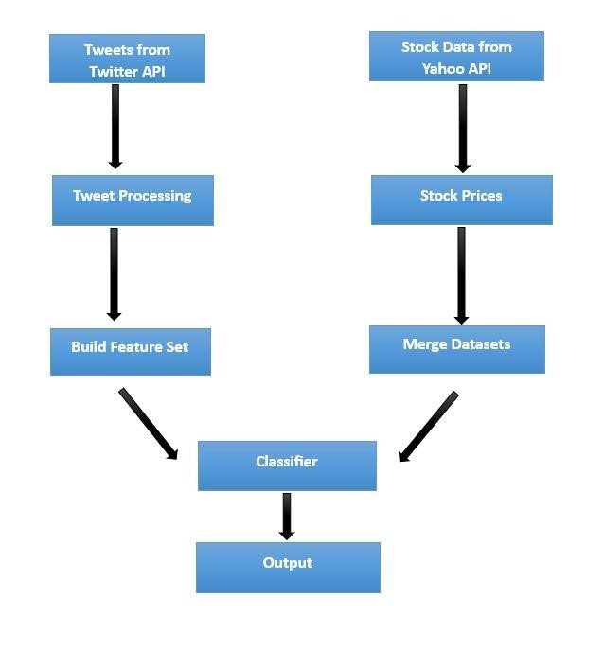

Fig 3.1 Architecture of the system

The Architecture diagram illustrates a comprehensive workflow for predicting stock prices by integrating sentiment analysis from tweets and historical stock data. Initially, tweets are collected using the Twitter API, followed by twehistorical stock prices are retrieved via the Yahoo Finance API. These stock prices are then merged with the tweetderived feature set to create a cohesive dataset. This combined dataset is fed into a

classifier, which is trained to predict stock price movements based on both sentiment and historical price data. The classifier's output provides the final stock price predictions, leveraging the integrated information from both sentiment analysis and financial data.

A) Data Preprocessing
Data preprocessing for stock price prediction begins with comprehensive data collection from diverse sources such as stock-related tweets and Yahoo Finance. Stock tweets offer real-time sentiment data from investors and market enthusiasts, which can significantly impact stock prices. By scraping tweets containing stock symbols and relevant keywords, we can gauge the market sentiment and extract sentiment scores using natural language processing techniques.
Concurrently, Yahoo Finance provides detailed historical stock data, including open, high, low, close prices, and trading volumes, along with financial news articles. Integrating these datasets involves cleaning the data to handle missing values, removing duplicates, and ensuring consistent formatting. This process ensures that the final dataset is robust and reliable, combining quantitative financial data with qualitative sentiment analysis, ultimately enhancing the predictive power of the machine learning models.

B) Sentiment Analysis
Sentiment analysis significantly enhances stock price prediction by quantifying the market's emotional tone through textual data. The process begins by collecting relevant textual data, such as tweets about specific stocks and financial news from Yahoo Finance, which provide insights into public and investor sentiment. These insights are pivotal for forecasting stock movements.
To prepare the data for analysis, preprocessing steps are undertaken, including tokenization to break the text into individual words, stop word removal to eliminate common but uninformative words, and stemming or lemmatization to reduce words to their base forms. This standardization ensures that the text is clean and consistent.
Following preprocessing, sentiment scores are assigned using methods such as lexicon-based approaches like VADER, which uses predefined dictionaries to assess sentiment, or machine learning models trained on labelled sentiment datasets for more accurate predictions.
The integration of sentiment scores with financial data creates a comprehensive dataset that encompasses both market sentiment and historical stock performance. This enriched dataset is utilized to extract relevant features train predictive machine learning models. These models, which may include algorithms such as regression, decision trees, or neural networks, learn the relationships between sentiment and stock prices, ultimately improving the accuracy of stock price predictions. By combining emotional insights with quantitative data, the models enhance forecasting capabilities and support more informed trading and investment decisions.

C)Feature Extraction
In the model selection phase for predicting stock prices, two key algorithms are considered: Support Vector Machine (SVM) and Random Forest.
Support Vector Machine (SVM) is utilized to model the relationship between tweet sentiments, historical stock prices, and future stock prices. Its performance is tuned using parameters such as the regularization parameter (C), kernel type (linear, polynomial, RBF), and epsilon, with optimal values identified through grid search and cross-validation. SVM is valued for its ability to handle complex relationships and resist overfitting.
Random Forest, on the other hand, is used for its capacity to manage numerous features and capture nonlinear relationships. Key parameters include the number of trees, maximum depth, and minimum samples for node splitting.
Both models are trained and evaluated using metrics like Mean Absolute Error (MAE), Mean Squared Error (MSE), and Root Mean Squared Error (RMSE). Cross-validation is applied to prevent overfitting. Random Forest's feature importance analysis reveals predictive features, while SVM's kernel trick captures non-linear patterns. The model with the highest accuracy and lowest prediction error on the validation set is selected as the final model, ensuring effective stock price prediction based on sentiment analysis and historical data.

D)Model Training
Model training for stock price prediction involves preparing the dataset, selecting algorithms, tuning hyperparameters, and evaluating performance. The dataset, which combines sentiment scores from tweets and historical stock prices from Yahoo Finance, is split into training and testing sets. For Random Forest, multiple decision trees are constructed, and hyperparameters such as the number of trees (n_estimators), maximum depth (max_depth), and minimum samples to split a node (min_samples_split) are fine-tuned using grid search with cross-validation.
Random Forest, with its ability to handle large feature sets and capture non-linear relationships, is expected to perform robustly. Meanwhile, SVM's capability to work in high-dimensional spaces and capture complex patterns makes it a strong contender. The model that exhibits the lowest prediction error and best generalization to new data is selected for final deployment. This rigorous training and evaluation process ensures that the chosen model leverages the combined information from sentiment analysis and historical financial data to provide accurate and reliable stock price predictions.

E) Prediction
Attribute details such as historical stock prices, trading volumes, economic indicators, and sentiment analysis from news and social media could be the attributes inputted into the web application. The integrated machine learning model, such as a regression model, neural network, or ensemble method, would then process this data to predict future stock movements. Users, typically investors or financial professionals, would enter these data points into the interface, and the model would provide immediate feedback on the predicted direction of the stock (e.g., whether it's likely to increase, decrease, or remain stable) based on the input data. This predictive capability enables users to make informed investment decisions and take timely actions, thereby potentially improving investment outcomes.

3.2 DATA FLOW DIAGRAM

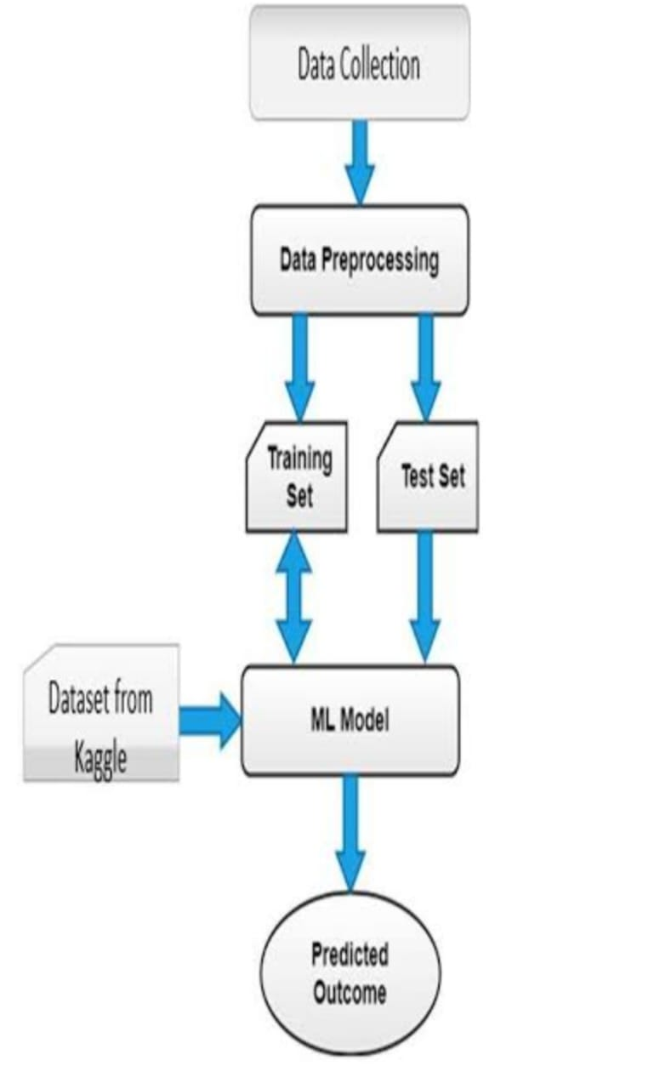

3.3 USE CASE DIAGRAMS

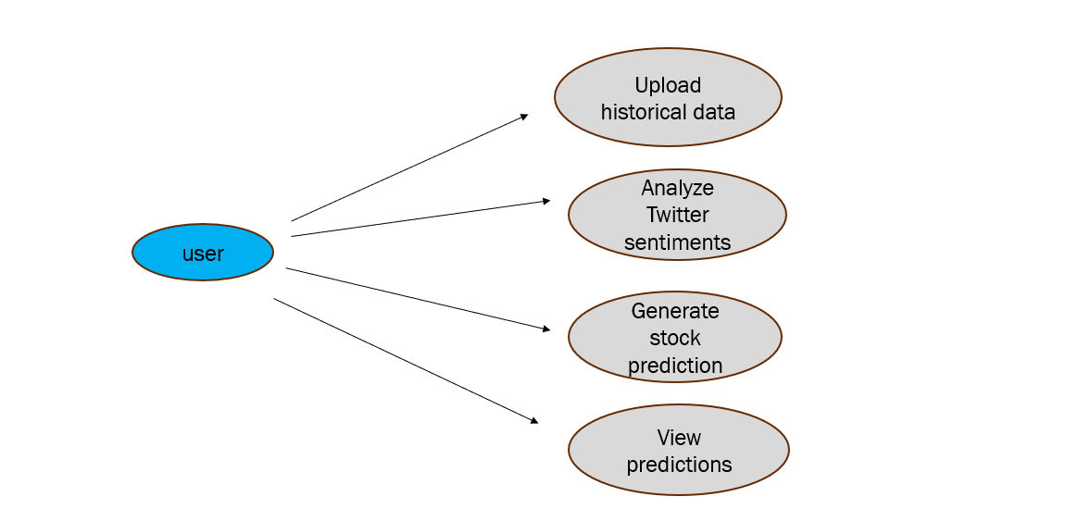

4.Module Design

4.1 Implementation of Modules

In the stock market prediction project, we developed a robust and reliable predictive model by leveraging a combination of Random Forest and Linear Discriminant Analysis (LDA). The process began with the comprehensive collection of historical stock prices and relevant financial indicators from multiple sources. This data provided a foundation for understanding market trends and behaviours.
Data preprocessing was a critical step, which involved several key activities to ensure the quality and usability of the data. We addressed missing values through imputation or removal, normalized the data to bring all features to a common scale, and performed feature selection to identify the most relevant predictors for stock price movements.
For model implementation, we initially applied LDA, a technique used for dimensionality reduction. LDA helped in reducing the number of features in the dataset while preserving the most significant information needed for stock price prediction. By focusing on the most relevant features, LDA enhanced the efficiency of the subsequent modelling phase.
Following LDA, we utilized the Random Forest algorithm to build our predictive model. Random Forest is known for its high accuracy and capability to manage large datasets with numerous features. This ensemble learning method constructs multiple decision trees during training and merges their predictions to produce a more accurate and generalized output. The ability of Random Forest to capture complex patterns and relationships in the data was crucial for improving prediction performance. We trained the model using a subset of the dataset and then validated its effectiveness through various performance metrics, including accuracy, precision, recall, and F1 score.
By combining LDA for dimensionality reduction with the powerful ensemble method of Random Forest, we achieved a balanced approach that effectively reduced complexity while enhancing predictive accuracy. This integrated approach provided a reliable tool for forecasting stock market trends and movements, demonstrating the efficacy of using advanced machine learning techniques in financial prediction.

Module 1: Data Collection and Preparation
Module 1 encompasses the critical processes involved in collecting and preparing datasets for effective stock market prediction. The module initiates with the gathering of diverse datasets from various sources, including reputable public repositories like Kaggle and GitHub. These repositories often provide rich datasets with historical stock prices, trading volumes, financial indicators, and other relevant information essential for accurate predictions.
Once the datasets are collected, the next step is to merge them into a unified, comprehensive data frame. This integration involves aligning data from different sources to ensure consistency and completeness. During this merging process, special attention is given to aligning timestamps, stock symbols, and other key attributes to create a coherent dataset that reflects all relevant aspects of the stock market.
Handling missing values is a crucial part of data preparation. In this module, missing values within the dataset are addressed through various imputation techniques. Typically, missing values are replaced with statistical measures such as the mode (most frequent value) or mean, depending on the nature of the data. This step is essential to preserve the integrity of the dataset and ensure that the analysis is based on complete and accurate information.
After addressing missing values, the module focuses on generating the final dataset with a specified number of records. This dataset is curated to include all necessary data points for subsequent processing and analysis. The final dataset is prepared to be used in further stages of the stock market prediction project, ensuring that it is robust, clean, and ready for advanced modelling and analysis.
Overall, Module 1 lays the foundation for effective stock market prediction by establishing a solid dataset through meticulous collection, merging, and preparation processes. This comprehensive approach ensures that the data is reliable and well-structured, setting the stage for successful predictive modelling and analysis in later stages of the project.

Module 2: Data Transformation and Algorithm Application
The implementation began with training the Random Forest model on the transformed dataset. This dataset had undergone preprocessing steps, including dimensionality reduction via Linear Discriminant Analysis (LDA), which reduced the number of features while preserving key information. The Random Forest algorithm was wellsuited for this transformed dataset due to its strength in handling large volumes of data and numerous features without overfitting.
Random Forest operates by constructing a multitude of decision trees during training. Each tree is built using a random subset of features and samples from the dataset, which helps in capturing various patterns and relationships within the data. Once the trees are trained, their predictions are aggregated to make a final prediction. This ensemble approach improves the model's robustness and accuracy, as it reduces the risk of overfitting and variance that can occur with individual decision trees.

To ensure the model's effectiveness, we validated its performance using several metrics, including
accuracy, precision, recall, and F1 score. Accuracy measures the overall correctness of the model's predictions, while precision and recall provide insights into the model’s performance on specific classes. The F1 score, which is the harmonic mean of precision and recall, offers a balanced view of the model's performance, particularly in cases of imbalanced datasets.
The combination of LDA for dimensionality reduction and Random Forest for prediction provided a powerful tool for forecasting stock market movements. LDA helped in simplifying the dataset by focusing on the most significant features, while Random Forest utilized this refined data to deliver high predictive performance. The result was a model that effectively balanced the need for reduced dimensionality with the capability to handle complex, high-dimensional data, offering a reliable and accurate forecasting tool for stock market prediction.

Module 3: Model Evaluation and Deployment
In Module 3 focused on evaluating and deploying the predictive model for stock market prediction. Following data transformation and algorithm application, this phase ensured the model's performance was thoroughly assessed for practical use. The process began with training the Random Forest algorithm on a substantial portion of the transformed dataset. Known for its robustness and ability to handle complex datasets, Random Forest was ideal. Hyperparameters such as the number of trees, maximum depth, and minimum samples for splits were adjusted to optimize performance.
The model was then evaluated on a separate validation set not used during training to determine its generalizability. Performance metrics included accuracy (overall correctness), precision (reliability of positive predictions), recall (sensitivity), and F1 score (balance of precision and recall). These metrics provided a comprehensive understanding of the model's effectiveness in predicting stock price movements. After demonstrating satisfactory performance, the model was prepared for deployment. This involved integrating the model into a real-time prediction system to analyse incoming data and generate forecasts, with infrastructure set up for data inputs, model inference, and result dissemination.
In summary, Module 3 ensured the Random Forest model was rigorously evaluated and fine-tuned, resulting in a reliable tool for predicting stock market movements, validated by accuracy, precision, recall, and F1 score metrics.

4.2 Random Forest
Stock market prediction project, after implementing data transformation and applying algorithms, we moved on to model evaluation and deployment using the Random Forest algorithm. The model was first trained on a portion of the transformed dataset using Random Forest, an ensemble learning method that constructs multiple decision trees and merges their results for improved accuracy. To assess its performance, we validated the model on a separate test set, using metrics such as accuracy, precision, recall, and F1 score.

To further ensure robustness, we performed cross-validation, splitting the data into multiple folds and
training the model on different subsets to mitigate overfitting and improve generalizability. The model's
predictions were compared against actual stock prices to evaluate its practical applicability and reliability. Once
validated, the model was deployed in a production environment. This involved integrating the model into a real-
time system that could continuously receive and process new data. We set up automated data pipelines for real-
time data collection, preprocessing, and feature extraction. The deployed Random Forest model could then make
real-time predictions, providing timely and actionable insights for stock market investors. Monitoring and
maintenance processes were established to track the model's performance over time, ensuring it remained accurate
and relevant in a dynamic market environment.
.

4.3 Linear Discriminant Analysis
In the stock market prediction project, after implementing data transformation and applying algorithms, we moved on to model evaluation and deployment, incorporating Linear Discriminant Analysis (LDA) alongside Random Forest. LDA was applied to the transformed dataset to reduce dimensionality and highlight the most significant features, streamlining the dataset and improving model efficiency.

The model, incorporating both LDA and Random Forest, was trained on a portion of the dataset. To assess its performance, we validated the model on a separate test set, using metrics such as accuracy, precision, recall, and F1 score. These metrics provided a comprehensive understanding of the model's effectiveness in predicting stock price movements.
To further ensure robustness, we performed cross-validation, splitting the data into multiple folds and training the model on different subsets to mitigate overfitting and improve generalizability. The model's predictions were compared against actual stock prices to evaluate its practical applicability and reliability.
Once validated, the model was deployed in a production environment. This involved integrating the model into a real-time system that could continuously receive and process new data. We set up automated data pipelines for real-time data collection, preprocessing, and feature extraction. The deployed model, enhanced by LDA for dimensionality reduction and Random Forest for prediction, could then make real-time predictions, providing timely and actionable insights for stock market investors. Monitoring and maintenance processes were established to track the model's performance over time, ensuring it remained accurate and relevant in a dynamic market environment.

4.4 Sample code

from flask import Flask, request, render_template
import pandas as pd
from textblob import TextBlob
import os

app = Flask(__name__)

# Paths to the datasets
UPLOAD_FOLDER = 'uploads'
STOCK_NEWS_FILE = 'stock_tweets.csv'
STOCK_DATA_FILE = 'stock_yfinance_data.csv'

# Function to initialize datasets
def initialize_datasets():
# Check and load datasets
if not os.path.exists(UPLOAD_FOLDER):
os.makedirs(UPLOAD_FOLDER)

# File paths
stock_news_path = os.path.join(UPLOAD_FOLDER, STOCK_NEWS_FILE)
stock_data_path = os.path.join(UPLOAD_FOLDER, STOCK_DATA_FILE)

# Load datasets
stock_news_df = pd.read_csv(stock_news_path)
stock_data_df = pd.read_csv(stock_data_path)

# Clean and parse date columns
stock_news_df['Date'] = pd.to_datetime(stock_news_df['Date'])
stock_data_df['Date'] = pd.to_datetime(stock_data_df['Date'])

# Check if datetime columns are timezone-aware and convert if needed
if stock_news_df['Date'].dt.tz is None:
stock_news_df['Date'] = stock_news_df['Date'].dt.tz_localize('UTC')
else:
stock_news_df['Date'] = stock_news_df['Date'].dt.tz_convert('UTC')

if stock_data_df['Date'].dt.tz is None:
stock_data_df['Date'] = stock_data_df['Date'].dt.tz_localize('UTC')
else:
stock_data_df['Date'] = stock_data_df['Date'].dt.tz_convert('UTC')

return stock_news_df, stock_data_df

# Function to process and analyze data
def analyze_stock_data(company_name, start_date, end_date):
stock_news_df, stock_data_df = initialize_datasets()

# Convert start_date and end_date to Timestamp and localize to UTC
start_date = pd.Timestamp(start_date).tz_localize('UTC')
end_date = pd.Timestamp(end_date).tz_localize('UTC')

# Filter data by company name and date range
filtered_news_df = stock_news_df[
(stock_news_df['CompanyName'].str.contains(company_name, case=False, na=False)) &
(stock_news_df['Date'] >= start_date) &
(stock_news_df['Date'] <= end_date)
]

if filtered_news_df.empty:
print("No matching data found. Check the following:")
print("Unique Stock Names:", stock_news_df['CompanyName'].unique())
print("Date Range in Data:", stock_news_df['Date'].min(), "-", stock_news_df['Date'].max())
print(f"Filter Inputs: company_name={company_name}, start_date={start_date}, end_date={end_date}")

filtered_stock_data_df = stock_data_df[
(stock_data_df['Date'] >= start_date) &
(stock_data_df['Date'] <= end_date)
]

if filtered_stock_data_df.empty:
average_closing_price = "No data"
else:
average_closing_price = filtered_stock_data_df['Close'].mean()

if not filtered_news_df.empty:
filtered_news_df['Polarity'] = filtered_news_df['Tweet'].apply(lambda tweet: TextBlob(tweet).sentiment.polarity)
positive_tweets = (filtered_news_df['Polarity'] > 0).sum()
negative_tweets = (filtered_news_df['Polarity'] < 0).sum()
neutral_tweets = (filtered_news_df['Polarity'] == 0).sum()

total_tweets = len(filtered_news_df)
positive_percentage = (positive_tweets / total_tweets) * 100
negative_percentage = (negative_tweets / total_tweets) * 100
neutral_percentage = (neutral_tweets / total_tweets) * 100
else:
positive_percentage = negative_percentage = neutral_percentage = 0

return {
'average_closing_price': average_closing_price,
'positive_percentage': positive_percentage,
'negative_percentage': negative_percentage,
'neutral_percentage': neutral_percentage,
}

@app.route('/')
def index():
return render_template('index.html')

@app.route('/process', methods=['POST'])
def process():
company_name = request.form['company_name']
start_date = request.form['start_date']
end_date = request.form['end_date']

result = analyze_stock_data(company_name, start_date, end_date)

# Find the company name corresponding to the given stock name
stock_news_df, _ = initialize_datasets()
company_name_from_df = stock_news_df[
stock_news_df['StockName'].str.contains(company_name, case=False, na=False)
]['CompanyName'].dropna().unique()

# If there are multiple or no matches, handle accordingly
if len(company_name_from_df) == 1:
company_name_display = company_name_from_df[0]
else:
company_name_display = company_name # Use the input name if no unique match

return render_template('result.html', result=result, company_name=company_name_display)

if __name__ == '__main__':
app.run(debug=True)

4.5 sample data set 1

Date,Tweet,StockName,CompanyName
2024-09-29 23:41:16+00:00,"Mainstream media has done an amazing job at brainwashing people. Today at
work, we were asked what companies we believe in &amp; I said @Tesla because they make the safest cars
&amp; EVERYONE disagreed with me because they heard“they catch on fire &amp; the batteries cost 20k to
replace”",TSLA,"Tesla, Inc."
2024-09-29 23:24:43+00:00,Tesla delivery estimates are at around 364k from the analysts. $tsla,TSLA,"Tesla,
Inc."
2024-09-29 23:18:08+00:00,"3/ Even if I include 63.0M unvested RSUs as of 6/30, additional equity needed for
the RSUs is 63.0M x $54.20 = $3.4B. If the deal closed tomorrow at $54.20, Elon would need $2.0B for existing
shares plus $3.4B for RSUs, so $5.4B new equity. $twtr $tsla",TSLA,"Tesla, Inc."
2024-09-29 22:40:07+00:00,"@RealDanODowd @WholeMarsBlog @Tesla Hahaha why are you still trying to
stop Tesla FSD bro! Get your shit together and make something better? Thats how companies work, they
competed. Crying big old ass fart clown!",TSLA,"Tesla, Inc."
2024-09-29 22:27:05+00:00,"@RealDanODowd @Tesla Stop trying to kill kids, you sad deranged old
man",TSLA,"Tesla, Inc."
2024-09-29 22:25:53+00:00,@RealDanODowd @Tesla This is you https://t.co/3Ml1XawSEb,TSLA,"Tesla,
Inc."
2024-09-29 22:24:22+00:00,"For years @WholeMarsBlog viciously silenced @Tesla critics. Failing to silence
me, he desperately lashes out with childish insults about me, my company, my products - and even my 💩! His
fear and impotence spurs me on to ensure that everyone understands Full Self-Driving is💩.
https://t.co/lw84VzwW5U",TSLA,"Tesla, Inc."
2024-09-29 22:23:54+00:00,"$NIO just because I'm down money doesn't mean this is a bad investment. The
whole market, everything sucks right now. 2-5 years from now, I'm confident it will pay off. Long the best
$AAPL $AMZN $TSLA $GOOGL $NIO",TSLA,"Tesla, Inc."
2024-09-29 22:23:28+00:00,"50 likes for some $SPY $TSLA charts to study!

❤️",TSLA,"Tesla, Inc."
2024-09-29 22:15:01+00:00,"@MrJames__321 @KellyRoofing @TeslaSolar @elonmusk @Tesla The
powerwalls themselves are waterproof, but what could be bad is any wiring in the house that could be
damaged.",TSLA,"Tesla, Inc."
2024-09-29 21:58:00+00:00,"Tomorrow, Tesla, $TSLA, AI day 2 is ongoing.

Unusual Whales is bringing some Tesla experts to discuss what to expect and $TSLA generally.

Join below to prepare before the event at 6:55PM EST:

https://t.co/hObh7OdVs5",TSLA,"Tesla, Inc."
2024-09-29 21:33:05+00:00,Powerwall FTW! https://t.co/GWAaXXCrYv,TSLA,"Tesla, Inc."
2024-09-29 21:11:30+00:00,"$TSLAQ: Tesla’s dead in Europe! Everyone else is passing $TSLA in the EU now
in EV unit sales! If you don’t believe us, go to eu-evs and see for yourself!

Me: &lt;goes to eu-evs&gt; 🧐 https://t.co/GAyiZAKF56",TSLA,"Tesla, Inc."
2024-09-29 21:00:25+00:00,The irony is so thick you can cut it with a knife. @Tesla
https://t.co/8CihPdpns7,TSLA,"Tesla, Inc."
2024-09-29 20:15:41+00:00,Tesla AI day in 24 hours. Are you ready? $TSLA rocks big time.
https://t.co/GxtdO2utB4,TSLA,"Tesla, Inc."
2024-09-29 19:38:29+00:00,Picked up some $TSLA shares at $269 https://t.co/4UQVchSs2R,TSLA,"Tesla,
Inc."
2024-09-29 19:36:59+00:00,"2/ Even if @elonmusk loses the $TWTR trial (would more likely settle at $51-
$52/share), Elon would only have to raise $2-$3B more from $TSLA sales (raised $15B equity) to fund the
equity needed to complete the deal, assuming the $7B 3P equity and $13B debt financing still intact.
https://t.co/PqtHF2sSmJ",TSLA,"Tesla, Inc."
2024-09-29 19:27:54+00:00,"Everyone should keep a long term perspective. It’s always darkest before the
dawn. With 2026 EPS of $20.80, at 40x P/E (2x PEG), $TSLA worth $832 by 2026. Discounting this back at
13.6% (4.0% 10yrTY, 6% ERP, 1.6x beta), $TSLA value $550. That’s 100% upside over 6-12 mos.
https://t.co/oPn2JMXBrh",TSLA,"Tesla, Inc."
2024-09-29 19:24:50+00:00,$TSLA Cybertruck can act as a boat according to Elon.
https://t.co/aahIkZwUCT,TSLA,"Tesla, Inc."
2024-09-29 19:17:48+00:00,"#GigaBerlinBrandenburg
@tesla destination chargers are ready to charge all electric vehicles, not just Tesla, for all employees.
https://t.co/EfecEy3CQu",TSLA,"Tesla, Inc."
2024-09-29 19:12:32+00:00,"According to California rules that are now also being adopted by New York state,
69% of all new cars sold will have to be EVs by 2030. @elonmusk $TSLA",TSLA,"Tesla, Inc."
2024-09-29 19:10:37+00:00,"“New York state plans to adopt California's rules approved in August that would
require all new vehicles sold in the state by 2035 to be either electric or plug-in electric hybrids, Governor Kathy
Hochul said Thursday” — Reuters $TSLA",TSLA,"Tesla, Inc."
2024-09-29 19:08:03+00:00,@KellyRoofing @TeslaSolar @elonmusk @Tesla But $TSLA is just a car
company and the auto analysts are the only ones that should value it….. 🙄,TSLA,"Tesla, Inc."
2024-09-29 19:01:22+00:00,"Tomorrow, Tesla, $TSLA, AI day 2 is ongoing.

Unusual Whales is bringing some Tesla experts to discuss, including:

@GerberKawasaki
@WholeMarsBlog
@jasondebolt
@teslaherbert
@WR4NYGov

&amp; more!

Join below to prepare before the event at 6:55PM EST:
https://t.co/D2PPPVps5Q",TSLA,"Tesla, Inc."
2024-09-29 18:48:36+00:00,Time for me to wrap up things for next 10 days and walk away from the markets
and enjoy some time off again. I'm holding all my shares as it makes no sense to panic sell this bloodbath today.
I'll check in when gone but everyone have a great week. AI and deliveries on deck. $TSLA
https://t.co/tTXJ02cssL,TSLA,"Tesla, Inc."
2024-09-29 18:46:07+00:00,"Today they're shooting the generals.
$AAPL $TSLA https://t.co/Jymw8fUpyq",TSLA,"Tesla, Inc."
2024-09-29 18:43:55+00:00,I think i’ll buy some $TSLA today before the close,TSLA,"Tesla, Inc."
2024-09-29 18:36:51+00:00,"Fuck what you heard, it’s Tesla AI day (part 2) tomorrow, where the world gets a
glimpse at Tesla’s most important product ever made. $TSLA",TSLA,"Tesla, Inc."
2024-09-29 18:23:20+00:00,This makes my day! #Tesla #hawaii $TSLA
https://t.co/OCLH7b3H39,TSLA,"Tesla, Inc."
2024-09-29 18:13:24+00:00,Even after being down 7% today the PE is 103x. Totally insane with growth having
plateaued and a 10% haircut to ASP from FX. Nobody should be surprised when $TSLAQ is a fraction of itself
in 6 months! $TSLA $TSLAQ,TSLA,"Tesla, Inc."
2024-09-29 18:10:14+00:00,"Tesla $TSLA Shares Could Rise in Coming Weeks Due to 3 Factors, Says Goldman Sachs

https://t.co/xl50r6gjeY",TSLA,"Tesla, Inc."
2024-09-29 18:05:22+00:00,Meanwhile things continue to go well at Tesla. Wouldn't know it from the stock
price however... $TSLA #AIday2,TSLA,"Tesla, Inc."
2024-09-29 18:01:17+00:00,This ugly mean bear market is working its way through. Creating huge
opportunities for investors who can see past this rate hike cycle. Which should be over soon. #tesla
$TSLA,TSLA,"Tesla, Inc."
2024-09-29 17:57:57+00:00,$tsla just retested the $798 pre-split level. Screaming buy now.
https://t.co/0TPBm60MyC,TSLA,"Tesla, Inc."
2024-09-29 17:42:24+00:00,"No way to sugarcoat $TSLA -6.9% today vs NDX -3.2%. Mainly due to Fed
officials hammering home the message that int rates still going higher. Instit’ns don’t expect much from AI Day
2, worry about 3Q China deliveries, and realize $TWTR v Musk proceeding not going well for Elon.
https://t.co/UmkfEln5xY",TSLA,"Tesla, Inc."
2024-09-29 17:41:43+00:00,"Friendly reminder to the $TSLA holders: As the value of $TSLA goes down, the
number of shares Elon will have to sell in case he has to buy $TWTR goes up.
https://t.co/De6coP8b0I",TSLA,"Tesla, Inc."
2024-09-29 17:40:44+00:00,"$TSLA along a few others the only interesting plays in a pretty choppy week--At
287, during a big green day, we said the bounce was corrective looking🤝 -7% since--As this and $AAPL catch
up with the rest of tech they can still offer some good R:R plays https://t.co/tFEQyY1312
https://t.co/CU2ESycCX1",TSLA,"Tesla, Inc."
2024-09-29 17:27:23+00:00,@vap1337 @Tesla All I see is a free Tesla,TSLA,"Tesla, Inc."
2024-09-29 17:16:23+00:00,"@TeslaSolar roof stood up to #HurricaneIan with 155mph winds and a 10’ storm
surge! This Powerwall was underwater for hours and is still working perfectly.

@elonmusk @Tesla #powerwall #solarroof https://t.co/V7443wwGwd",TSLA,"Tesla, Inc."
2024-09-29 17:11:40+00:00,"Rent checks coming in 2 days.

4.6 Sample data set 2

Date,Open,High,Low,Close,Adj Close,Volume,StockName
2021-09-30,260.3333435058594,263.0433349609375,258.3333435058594,258.49334716796875,258.49334716796875,53868000,TSLA
2021-10-01,259.4666748046875,260.260009765625,254.52999877929688,258.40667724609375,258.40667724609375,51094200,TSLA
2021-10-04,265.5,268.989990234375,258.7066650390625,260.510009765625,260.510009765625,91449900,TSLA
2021-10-05,261.6000061035156,265.7699890136719,258.0666809082031,260.1966552734375,260.1966552734375,55297800,TSLA
2021-10-06,258.73333740234375,262.2200012207031,257.739990234375,260.9166564941406,260.9166564941406,43898400,TSLA
2021-10-07,261.82000732421875,268.3333435058594,261.1266784667969,264.53668212890625,264.53668212890625,57587400,TSLA
2021-10-08,265.4033203125,265.4599914550781,260.3033447265625,261.8299865722656,261.8299865722656,50215800,TSLA
2021-10-11,262.54998779296875,267.0799865722656,261.8333435058594,263.9800109863281,263.9800109863281,42600900,TSLA
2021-10-12,266.9766540527344,270.7733459472656,265.5233459472656,268.5733337402344,268.5733337402344,66060000,TSLA
2021-10-13,270.15667724609375,271.8033447265625,268.59332275390625,270.3599853515625,270.3599853515625,42360300,TSLA
2021-10-14,271.8299865722656,273.4166564941406,271.1166687011719,272.7733459472656,272.7733459472656,36741600,TSLA
2021-10-15,274.5799865722656,281.07000732421875,274.1166687011719,281.010009765625,281.010009765625,56773800,TSLA
2021-10-18,283.92999267578125,291.7533264160156,283.8233337402344,290.03668212890625,290.03668212890625,72621600,TSLA
2021-10-19,292.510009765625,292.6499938964844,287.5033264160156,288.0899963378906,288.0899963378906,52143300,TSLA
2021-10-20,288.45001220703125,289.8299865722656,285.7933349609375,288.6000061035156,288.6000061035156,42096300,TSLA
2021-10-21,285.3333435058594,300.0,285.1666564941406,298.0,298.0,94444500,TSLA
2021-10-22,298.5,303.3333435058594,296.9866638183594,303.2266540527344,303.2266540527344,68642400,TSLA
2021-10-25,316.84332275390625,348.3399963378906,314.73333740234375,341.6199951171875,341.6199951171875,188556300,TSLA
2021-10-26,341.5633239746094,364.9800109863281,333.8133239746094,339.4766540527344,339.4766540527344,187245000,TSLA
2021-10-27,346.5533447265625,356.9599914550781,343.59332275390625,345.9533386230469,345.9533386230469,115579500,TSLA
2021-10-28,356.10333251953125,360.3333435058594,351.3999938964844,359.0133361816406,359.0133361816406,81639600,TSLA
2021-10-29,360.6199951171875,371.7366638183594,357.7366638183594,371.3333435058594,371.3333435058594,89755200,TSLA
2021-11-01,381.6666564941406,403.25,372.88665771484375,402.86334228515625,402.86334228515625,168146100,TSLA
2021-11-02,386.4533386230469,402.86334228515625,382.0,390.6666564941406,390.6666564941406,128213400,TSLA
2021-11-03,392.4433288574219,405.1300048828125,384.2066650390625,404.6199951171875,404.6199951171875,103885500,TSLA
2021-11-04,411.4700012207031,414.4966735839844,405.6666564941406,409.9700012207031,409.9700012207031,76192200,TSLA

2021-11-05,409.3333435058594,413.2900085449219,402.6666564941406,407.36334228515625,407.36334228515625,64886400,TSLA
2021-11-08,383.2633361816406,399.0,377.6666564941406,387.64666748046875,387.64666748046875,100337100,TSLA
2021-11-09,391.20001220703125,391.5,337.17333984375,341.1666564941406,341.1666564941406,177317400,TSLA
2021-11-10,336.8033447265625,359.3666687011719,329.10333251953125,355.98333740234375,355.98333740234375,128408100,TSLA
2021-11-11,367.5899963378906,368.3233337402344,351.55999755859375,354.5033264160156,354.5033264160156,67189800,TSLA
2021-11-12,349.1666564941406,351.5,339.73333740234375,344.47332763671875,344.47332763671875,76719300,TSLA
2021-11-15,339.2099914550781,343.99334716796875,326.20001220703125,337.7966613769531,337.7966613769531,104326800,TSLA
2021-11-16,334.4366760253906,352.3999938964844,334.05999755859375,351.57666015625,351.57666015625,79627200,TSLA
2021-11-17,354.5033264160156,373.21331787109375,351.8333435058594,363.0033264160156,363.0033264160156,94336200,TSLA
2021-11-18,368.8500061035156,370.6666564941406,358.3399963378906,365.4599914550781,365.4599914550781,62696700,TSLA
2021-11-19,366.2900085449219,379.5733337402344,364.23333740234375,379.0199890136719,379.0199890136719,64926900,TSLA
2021-11-22,387.4433288574219,400.6499938964844,377.4766540527344,385.6233215332031,385.6233215332031,99217500,TSLA
2021-11-23,389.1700134277344,393.5,354.23333740234375,369.6766662597656,369.6766662597656,108515100,TSLA
2021-11-24,360.1300048828125,377.5899963378906,354.0,372.0,372.0,67680600,TSLA
2021-11-26,366.489990234375,369.59332275390625,360.3333435058594,360.6400146484375,360.6400146484375,35042700,TSLA
2021-11-29,366.9966735839844,380.8900146484375,366.7300109863281,378.9966735839844,378.9966735839844,58393500,TSLA
2021-11-30,381.4566650390625,389.3333435058594,372.6666564941406,381.586669921875,381.586669921875,81276000,TSLA
2021-12-01,386.8999938964844,390.9466552734375,363.586669921875,365.0,365.0,68450400,TSLA
2021-12-02,366.35333251953125,371.0,352.2166748046875,361.5333251953125,361.5333251953125,73114800,TSLA
2021-12-03,361.5966796875,363.52667236328125,333.4033203125,338.3233337402344,338.3233337402344,92322000,TSLA
2021-12-06,333.836669921875,340.5466613769531,316.8333435058594,336.336669921875,336.336669921875,81663000,TSLA
2021-12-07,348.0666809082031,352.5566711425781,342.2699890136719,350.5833435058594,350.5833435058594,56084700,TSLA
2021-12-08,350.9033203125,357.4599914550781,344.3333435058594,356.32000732421875,356.32000732421875,41906400,TSLA
2021-12-09,353.5466613769531,354.163330078125,334.1199951171875,334.6000061035156,334.6000061035156,59438400,TSLA
2021-12-10,336.25,340.32666015625,327.510009765625,339.010009765625,339.010009765625,59664300,TSLA
2021-12-13,333.6966552734375,335.0,317.1400146484375,322.13665771484375,322.13665771484375,78595500,TSLA
2021-12-14,315.0,322.13665771484375,310.0,319.5033264160156,319.5033264160156,70806300,TSLA
2021-12-15,317.7366638183594,326.25,309.4166564941406,325.3299865722656,325.3299865722656,75169200,TSLA
5. test Cases
Test Cases
Test Case ID | Category | Test Case Name | Description | Input | Expected Output
TC-01 | Initialization | Dataset Directory Exists Check | Ensure the uploads directory exists or is created. | Directory path | Directory exists without errors.
TC-02 | Initialization | Load CSV Files | Validate the loading of stock_tweets.csv and stock_yfinance_data.csv. | File paths | Data Frames loaded successfully; no missing critical columns (e.g., Date, Stock Name, Close).
TC-03 | Data Preprocessing | Date Conversion to Datetime | Verify that Date columns in both datasets are converted to datetime format. | Datasets with Date column | Date column is in correct datetime format.
TC-04 | Data Preprocessing | Time zone Localization | Ensure Date columns are time zone-aware and localized to UTC. | Datasets with Date column | Date column is localized to UTC.
TC-05 | Data Filtering | Filter News and Stock Data by Date Range | Validate filtering functionality for stock news and data based on the given date range. | Start date, end date | Filtered datasets contain only rows within the specified date range.
TC-06 | Data Filtering | Filter News by Company Name | Ensure news data is filtered correctly based on the company name. | Company name | Filtered news contains only rows with the specified company name.
TC-07 | Analysis Functionality | Average Closing Price Calculation | Validate that the average closing price is calculated correctly for the filtered stock data. | Filtered stock data | Correct average closing price or "No data" if empty.
TC-08 | Sentiment Analysis | Sentiment Polarity Classification | Verify that sentiments (positive, negative, neutral) are correctly classified for each tweet. | Tweets from filtered news | Correct sentiment classification for each tweet.
TC-09 | Sentiment Analysis | Sentiment Percentage Calculation | Ensure sentiment percentages (positive, negative, neutral) are calculated correctly. | Total tweets, sentiment counts | Correct percentages calculated, summing to 100% or 0% for no tweets.
TC-10 | Edge Case Handling | Empty Datasets | Validate the behaviour when datasets are empty or missing data. | Empty datasets | Appropriate error messages or default outputs.
TC-11 | Edge Case Handling | Missing Columns | Check for appropriate handling of datasets missing required columns like Date, Tweet, or Close. | Incomplete datasets | Meaningful error messages or graceful handling.
TC-12 | API Endpoint | Index Page Rendering | Ensure the index page renders without issues. | GET request to / | Index page (HTML) loads successfully.
TC-13 | API Endpoint | Process Data Request | Validate that a POST request to /process with valid inputs processes data and returns correct results. | Valid company name, start and end dates | Rendered result page with calculated sentiment analysis and average closing price.
TC-14 | API Endpoint | Invalid Date Format | Ensure the system handles incorrect date formats gracefully. | Invalid start and end dates | Proper error message displayed without crashing.
TC-15 | API Endpoint | Unknown Company Name | Validate behaviour when the provided company name doesn't match any entries in the dataset. | Unknown company name | Result page with "No data" or appropriate feedback.
TC-16 | Performance | Large Dataset Handling | Test the system’s ability to handle large datasets without significant performance degradation. | Large datasets | Process completes within acceptable time limits.
TC-17 | Integration Testing | Template Rendering | Ensure templates index.html and result.html are rendered with the expected context variables. | Flask app, template files | Templates render correctly with all expected variables.
TC-18 | Security | Directory Traversal Protection | Validate protection against directory traversal attacks when accessing the uploads folder. | File paths with traversal attempts (e.g. /) | Requests denied or redirected to safe paths.
TC-19 | Input Validation | Missing Input Fields | Ensure behaviour when some input fields (company name, start date, end date) are missing from the request. | Request with missing fields | Error message displayed or default values used.

6. Results and Discussions

6.1 Comparison of Models

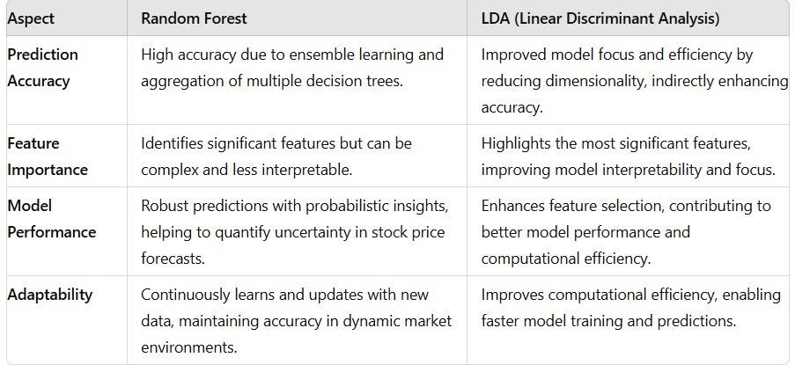
Fig 6.1.1 Comparison of Models

6.2 Model Performance Metrics
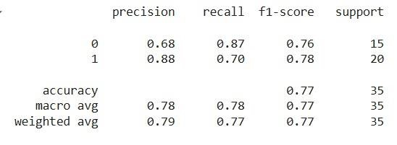

Fig 6.2.1 LDA Performance metrics

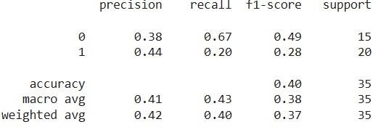
Fig 6.2.2 RF Performance metrics

6.3 Prediction of Stock Market

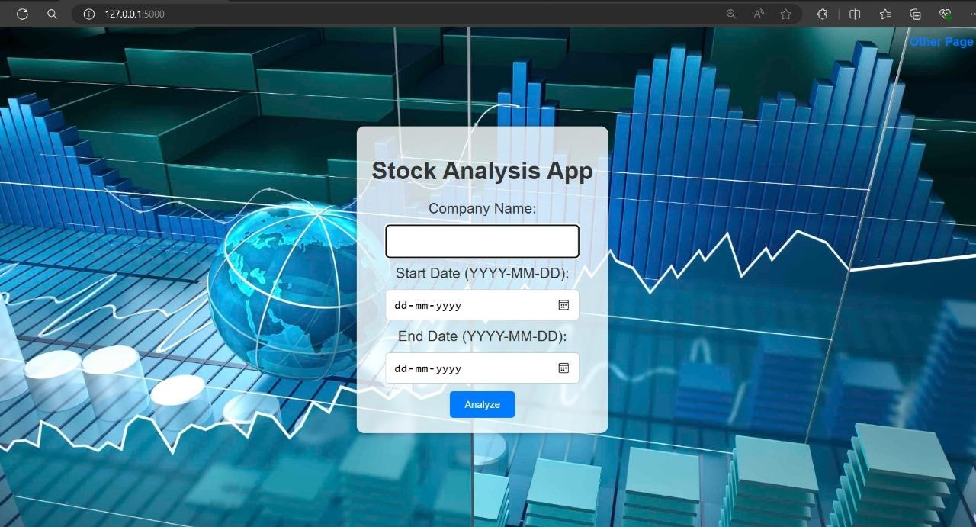

Fig 6.3.1 Interface

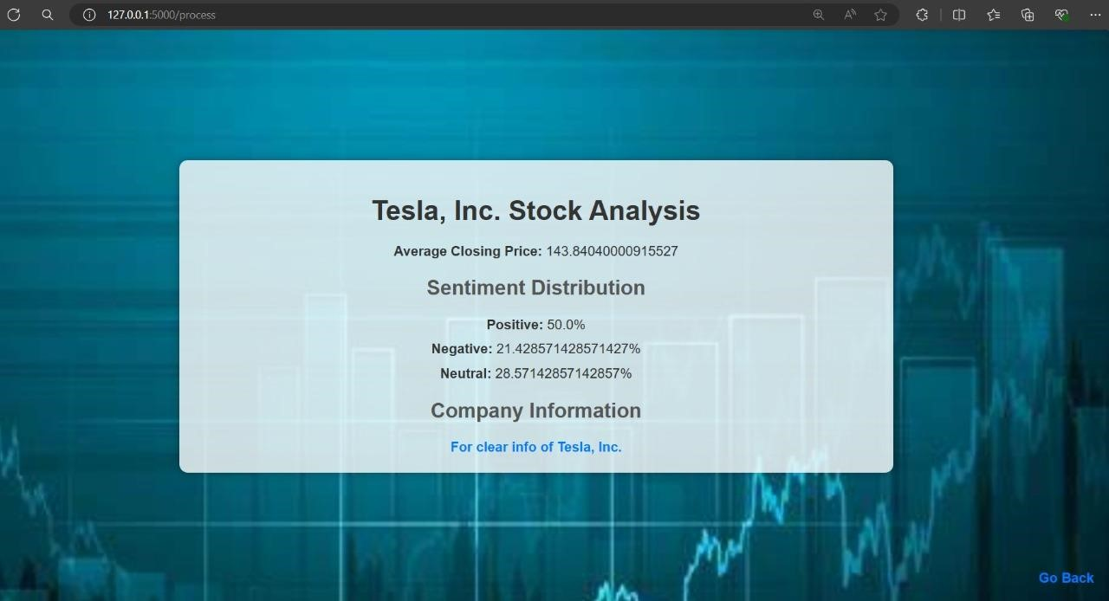

Fig 6.3.2 Stock Analysis

7. Conclusions and Future Enhancements

Conclusion:
The exchange rate forecasting project in utilizing algorithms provides a comprehensive framework for accurate and probabilistic predictions of stock-related rates.
Through the project, we have achieved the following:

1.Developed a Robust Methodology: The project implemented a structured methodology that includes data acquisition, pre-processing, feature selection using LDA, model building with Random Forest, and comprehensive model evaluation, ensuring a systematic approach to stock price prediction.

2.Enhanced Feature Selection with LDA: By using Linear Discriminant Analysis (LDA), the dimensionality of the dataset was effectively reduced, highlighting the most significant features and improving the model's focus and efficiency.

3.Utilized Random Forest for Robust Predictions: The Random Forest algorithm, with its ensemble approach, provided robust and accurate predictions by constructing multiple decision trees and aggregating their results, ensuring high prediction reliability.

4.Incorporated Relevant Factors: The model integrated a variety of relevant factors, including historical stock prices, economic indicators, and market sentiment data, capturing the complex interactions influencing stock price movements.

5.Provided Probabilistic Insights: The Random Forest model offered not just point predictions but also probabilistic insights, helping to quantify the uncertainty associated with stock price forecasts and providing a range of possible outcomes.

6.Rigorous Model Evaluation: Model performance was rigorously evaluated using metrics such as accuracy, precision, recall, and F1 score. This thorough evaluation confirmed the model's effectiveness in predicting stock price movements and facilitated continuous improvement.

7.Supported Informed Decision-Making: The project's outputs, including accurate stock price forecasts and uncertainty estimates, supported informed decision-making for investors, aiding in trading strategies, investment planning, and risk management.

8.Improved Computational Efficiency: The combination of LDA for dimensionality reduction and Random Forest for prediction improved computational efficiency, enabling faster model training and prediction without sacrificing accuracy.

By leveraging LDA for feature selection and Random Forest for robust prediction, this approach has proven effective in stock price forecasting, offering a solid foundation for further advancements to meet the evolving needs of financial markets.

Future Enhancements:

1.Advanced Modelling Techniques: Explore the incorporation of more advanced modelling techniques, such as state-space models, neural networks, or hybrid approaches combining Random Forest with deep learning algorithms like LSTM. These techniques can capture additional complexities and improve forecasting accuracy by leveraging the strengths of different models.

2.High-Frequency Data Integration: Extend the model to handle high-frequency data, such as intra-day trading data, to capture short-term market dynamics. This would improve the accuracy of real-time or intra-day stock price predictions. Developing efficient methodologies to process and analyse the increased volume and granularity of data is essential for this enhancement.

3.Dynamic Model Updating: Implement mechanisms for dynamically updating the model as new data becomes available. Approaches such as online learning or adaptive algorithms can allow the model to continuously learn and adjust to changing market conditions, ensuring its predictions remain relevant and accurate over time.

4.Incorporating Macro-Economic Indicators: Integrate additional macroeconomic indicators, such as interest rates, GDP growth, and inflation rates, into the forecasting model. Investigating the impact of these factors on stock price movements can provide a more comprehensive understanding and improve the overall predictive accuracy of the model.

5.Enhanced Volatility Modelling: Incorporate volatility modelling techniques, such as GARCH or stochastic volatility models, to capture time-varying volatility patterns in stock prices. Understanding the interaction between volatility and stock price movements can lead to more nuanced predictions, particularly in periods of market turbulence.

References:

- X. Wu, Q. Ye, H. Hong, and Y. Li, “Stock selection model based on machine learning with wisdom of experts and crowds,” IEEE Intell. Syst., vol. 35, no. 2, pp. 54–64, Mar. 2020.
- M. Jiang, L. Jia, Z. Chen, and W. Chen, “The two-stage machine learning ensemble models for stock price prediction by combining mode decomposition, extreme learning machine and improved harmony search algorithm,” Ann. Oper. Res., vol. 309, pp. 553–585, Jun. 2020.
- K. Yuan, G. Liu, J. Wu, and H. Xiong, “Dancing with Trump in the stock market: A deep information echoing model,” ACM Trans. Intell. Syst. Technol., vol. 11, no. 5, pp. 1–22, Oct. 2020.
- K. Nam and N. Seong, “Financial news-based stock movement prediction using causality analysis of influence in the Korean stock market,” Decis. Support Syst., vol. 117, pp. 100–112, Feb. 2019.
- J. Nikkinen and J. Peltomäki, “Crash fears and stock market effects: Evidence from web searches and printed news articles,” J. Behav. Finance, vol. 21, no. 2, pp. 117–127, 2019.
- S. Evert et al., “Combining machine learning and semantic features in the classification of corporate disclosures,” J. Log., Lang. Inf., vol. 28, no. 2, pp. 309–330, 2019.
- G. G. Creamer, “Network structure and market risk in the European equity market,” IEEE Syst. J., vol. 12, no. 2, pp. 1090–1098, Jun. 2018.
- F. Z. Xing, E. Cambria, and R. E. Welsch, “Natural language based financial forecasting: A survey,” Artif. Intell. Rev., vol. 50, no. 1, pp. 49–73, Jun. 2018.
- S. Feuerriegel and J. Gordon, “Long-term stock index forecasting based on text mining of regulatory disclosures,” Decis. Support Syst., vol. 112, pp. 88–97, Aug. 2018.
- D. C. Furlaneto, L. S. Oliveira, D. Menotti, and G. D. C. Cavalcanti, “Bias effect on predicting market trends with EMD,” Expert Syst. Appl., vol. 82, pp. 19–26, Oct. 2017.
- T. Fischer and C. Krauss, “Deep learning with long short-term memory networks for financial market predictions,” Eur. J. Oper. Res., vol. 270, no. 2, pp. 654–669, Dec. 2017.
- I. E. Fisher, M. R. Garnsey, and M. E. Hughes, “Natural language processing in accounting, auditing and finance: A synthesis of the literature with a roadmap for future research,” Intell. Syst. Accounting, Finance Manage., vol. 23, no. 3, pp. 157–214, Jul. 2016.

Glossary:

1.Tokenization: The process of breaking down text into smaller units, such as words or phrases, to facilitate analysis and processing in natural language processing (NLP).

2.Stemming: A text normalization technique that reduces words to their root or base form by removing suffixes (e.g., "running" to "run").

3.Lemmatization: Similar to stemming, lemmatization reduces words to their base or dictionary form, but it considers the context and grammatical structure (e.g., "better" to "good").

4.VADER: Valence Aware Dictionary and sEntiment Reasoner, a tool used for sentiment analysis that is particularly effective for analysing social media text.

5.TextBlob: A Python library for processing textual data, providing simple APIs for common NLP tasks such as sentiment analysis, noun phrase extraction, and classification.

6.Sentiment Indicators: Quantitative measures derived from sentiment analysis that reflect the overall mood or opinion of a group of texts, typically aggregated over a period of time.

7.Hyperparameter Tuning: The process of optimizing the parameters that control the learning process of a machine learning model to enhance its performance.

